Overview
RTP Cluster is software that sits between SIP signaling component (such as OpenSIPS, B2BUA, Kamailio etc.) and one or more RTPproxy instances. The software monitors availability of each individual RTPproxy and distributes load between them based on that availability and parameters defined by the administrator (weight and max capacity).

From the point of view of the signaling component, the RTP Cluster appears to be a normal RTPproxy running locally.

One process can support more than one cluster, each on different control socket.

The following diagram illustrates the high level design of the software.
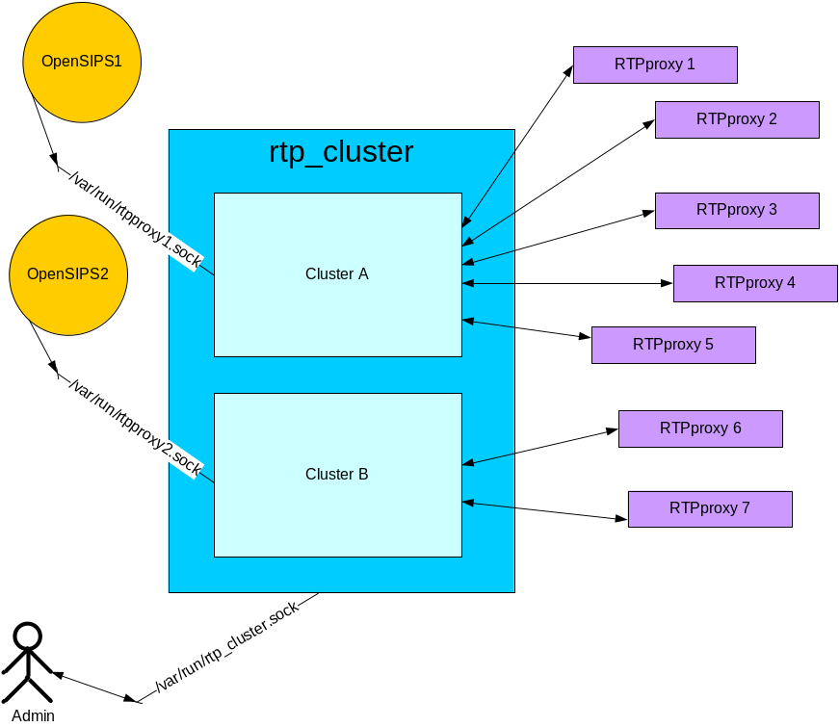

Installation and configuration
Installation currently consists of unpacking rtp_cluster tar package into designated directory.

Configuration is performed by the rtp_cluster.xml file. Example is available in the rtp_cluster directory of the package. Default location of the configuration file is /usr/local/etc/rtp_cluster.xml.

The server can be started as follows:

$ cd some/dir/rtp_cluster
$ python rtp_cluster.py

By default the software will become a daemon and run in background. All error messages and exceptions can be found in the /var/log/rtp_cluster.log. In order to run in the foreground mode one has to specify “-f” flag when starting rtp_cluster.py.

OpenSIPS configuration remains the same as in the case of stand-alone local RTPproxy.

Run-time configuration adjustments
RTP Cluster provides administration CLI interface allowing to change cluster configuration on the fly. In order to connect to that interface one can either use telnet utility (only works on systems where telnet can connect to unix domain sockets), or using the supplied rtp_cluster_client.py script. Following commands are supported:

- “ls” – list all configured clusters;
- “ls <cluster name>” – show detailed information about the cluster with the matching name;
- “modify <cluster name> add name=<rtpproxy name>,protocol=<protocol>,address=<address>,capacity=<capacity>,weight=<weight>” – add new RTPproxy into the cluster with matching name;
- “modify <cluster name> delete <rtpproxy name>” – gracefully remove specified RTPproxy from the cluster. The software will check if there any sessions already in progress and will wait for them to finish before removing the entry completely;
- “modify <cluster name> suspend <rtpproxy name>” – temporary suspend specified RTPproxy and do not create any new sessions in it. The proxy remains in the cluster configuration;
- “modify <cluster name> resume <rtpproxy name>” – resume previously suspended proxy.

Example:

1. Get list of configured clusters:

[sobomax@pioneer ~/sobosip/rtp_cluster]$ sudo ./rtp_cluster_client.py ls
Cluster: #0
name = Supercluster#1
address = /var/run/rtpproxy.sock
active members = 2
inactive members = 0

Cluster: #1
name = Supercluster#2
address = /var/run/rtpproxy1.sock
active members = 0
inactive members = 2
OK

2. Get detailed information about “Supercluster#1” cluster:

[sobomax@pioneer ~/sobosip/rtp_cluster]$ sudo ./rtp_cluster_client.py 'ls Supercluster#1'
Active members of the cluster #0:
RTPproxy: #0
name = RTPPROXY1
address = [u'127.0.0.1', 22222]
weight = 100
capacity = 2500
state = online
active sessions = 0
status = ACTIVE

RTPproxy: #1
name = RTPPROXY2
address = [u'127.0.0.1', 22223]
weight = 0
capacity = 1500
state = online
active sessions = 0
status = ACTIVE

Inactive members of the cluster #0:

OK

3. Add new proxy to the “Supercluster#2”:

[sobomax@pioneer ~/sobosip/rtp_cluster]$ sudo ./rtp_cluster_client.py 'modify Supercluster#2 add name=another_proxy,protocol=udp,address=1.2.3.4:567,capacity=120,weight=300'
OK

4. Gracefully remove “RTPPROXY2” from “Supercluster#1”:

[sobomax@pioneer ~/sobosip/rtp_cluster]$ sudo ./rtp_cluster_client.py 'modify Supercluster#1 delete RTPPROXY2'
OK

Current Limitations
- Cluster can only use unix domain socket for communicating with signaling component.
- Commands are case-sensitive. It’s suggested to use lower case to avoid any issues.
- Location of the configuration file is hardcoded and cannot be changed without modifying the source code.
- There is no command to create a cluster in run-time.

